**Week 12 KEY**

**Conceptual Questions**

1. In the phase diagram for water, why does the melting point curve have a negative slope?

Because ice is less dense than water.

1. Is the boiling point raised or lowered at higher elevations? Why?

The boiling point is LOWER at higher elevations because the external pressure is less, therefore the vapor pressure reaches the external pressure at a lower temperature.

1. The boiling point of butane (lighter fluid) is 30.2°F. Why is it a liquid in lighters at room temp?

If you exposed it to atmospheric pressure it would spontaneous evaporate, but it is kept under pressure inside lighters, so it remains a liquid (albeit an extremely volatile one) inside the lighter.

1. In the following titrations, would a reaction occur? If so, what would you expect the pH to be at the equivalence point? (<7, =7, >7)
   1. Sodium acetate titrated with HCl – Acetate converted to acetic acid, pH < 7 at eq. point
   2. Acetic acid titrated with HBr – Weak acid + strong acid = no reaction
   3. HClO4 titrated with KOH – Strong acid and strong base, pH = 7 at eq. point
2. Why is Cl2 a gas at room temperature, Br2 a liquid, and I2 a solid?

These are all non-polar molecules, but there are still London dispersion forces between the molecules. The larger the molecule, the more intermolecular forces, which raises the boiling point. bP - I2 > Br2 > Cl2

1. How many atoms occupy the unit cell of a simple cubic, body-centered cubic, and face-centered cubic structure?

Simple cubic = 1

Face-centered cubic = 4

Body-centered cubic = 2

**Chapter 10 Questions**

1. How much heat is required to change 0.50 mol of ice at -10.0 C into 0.5 mol of steam at 120°C?

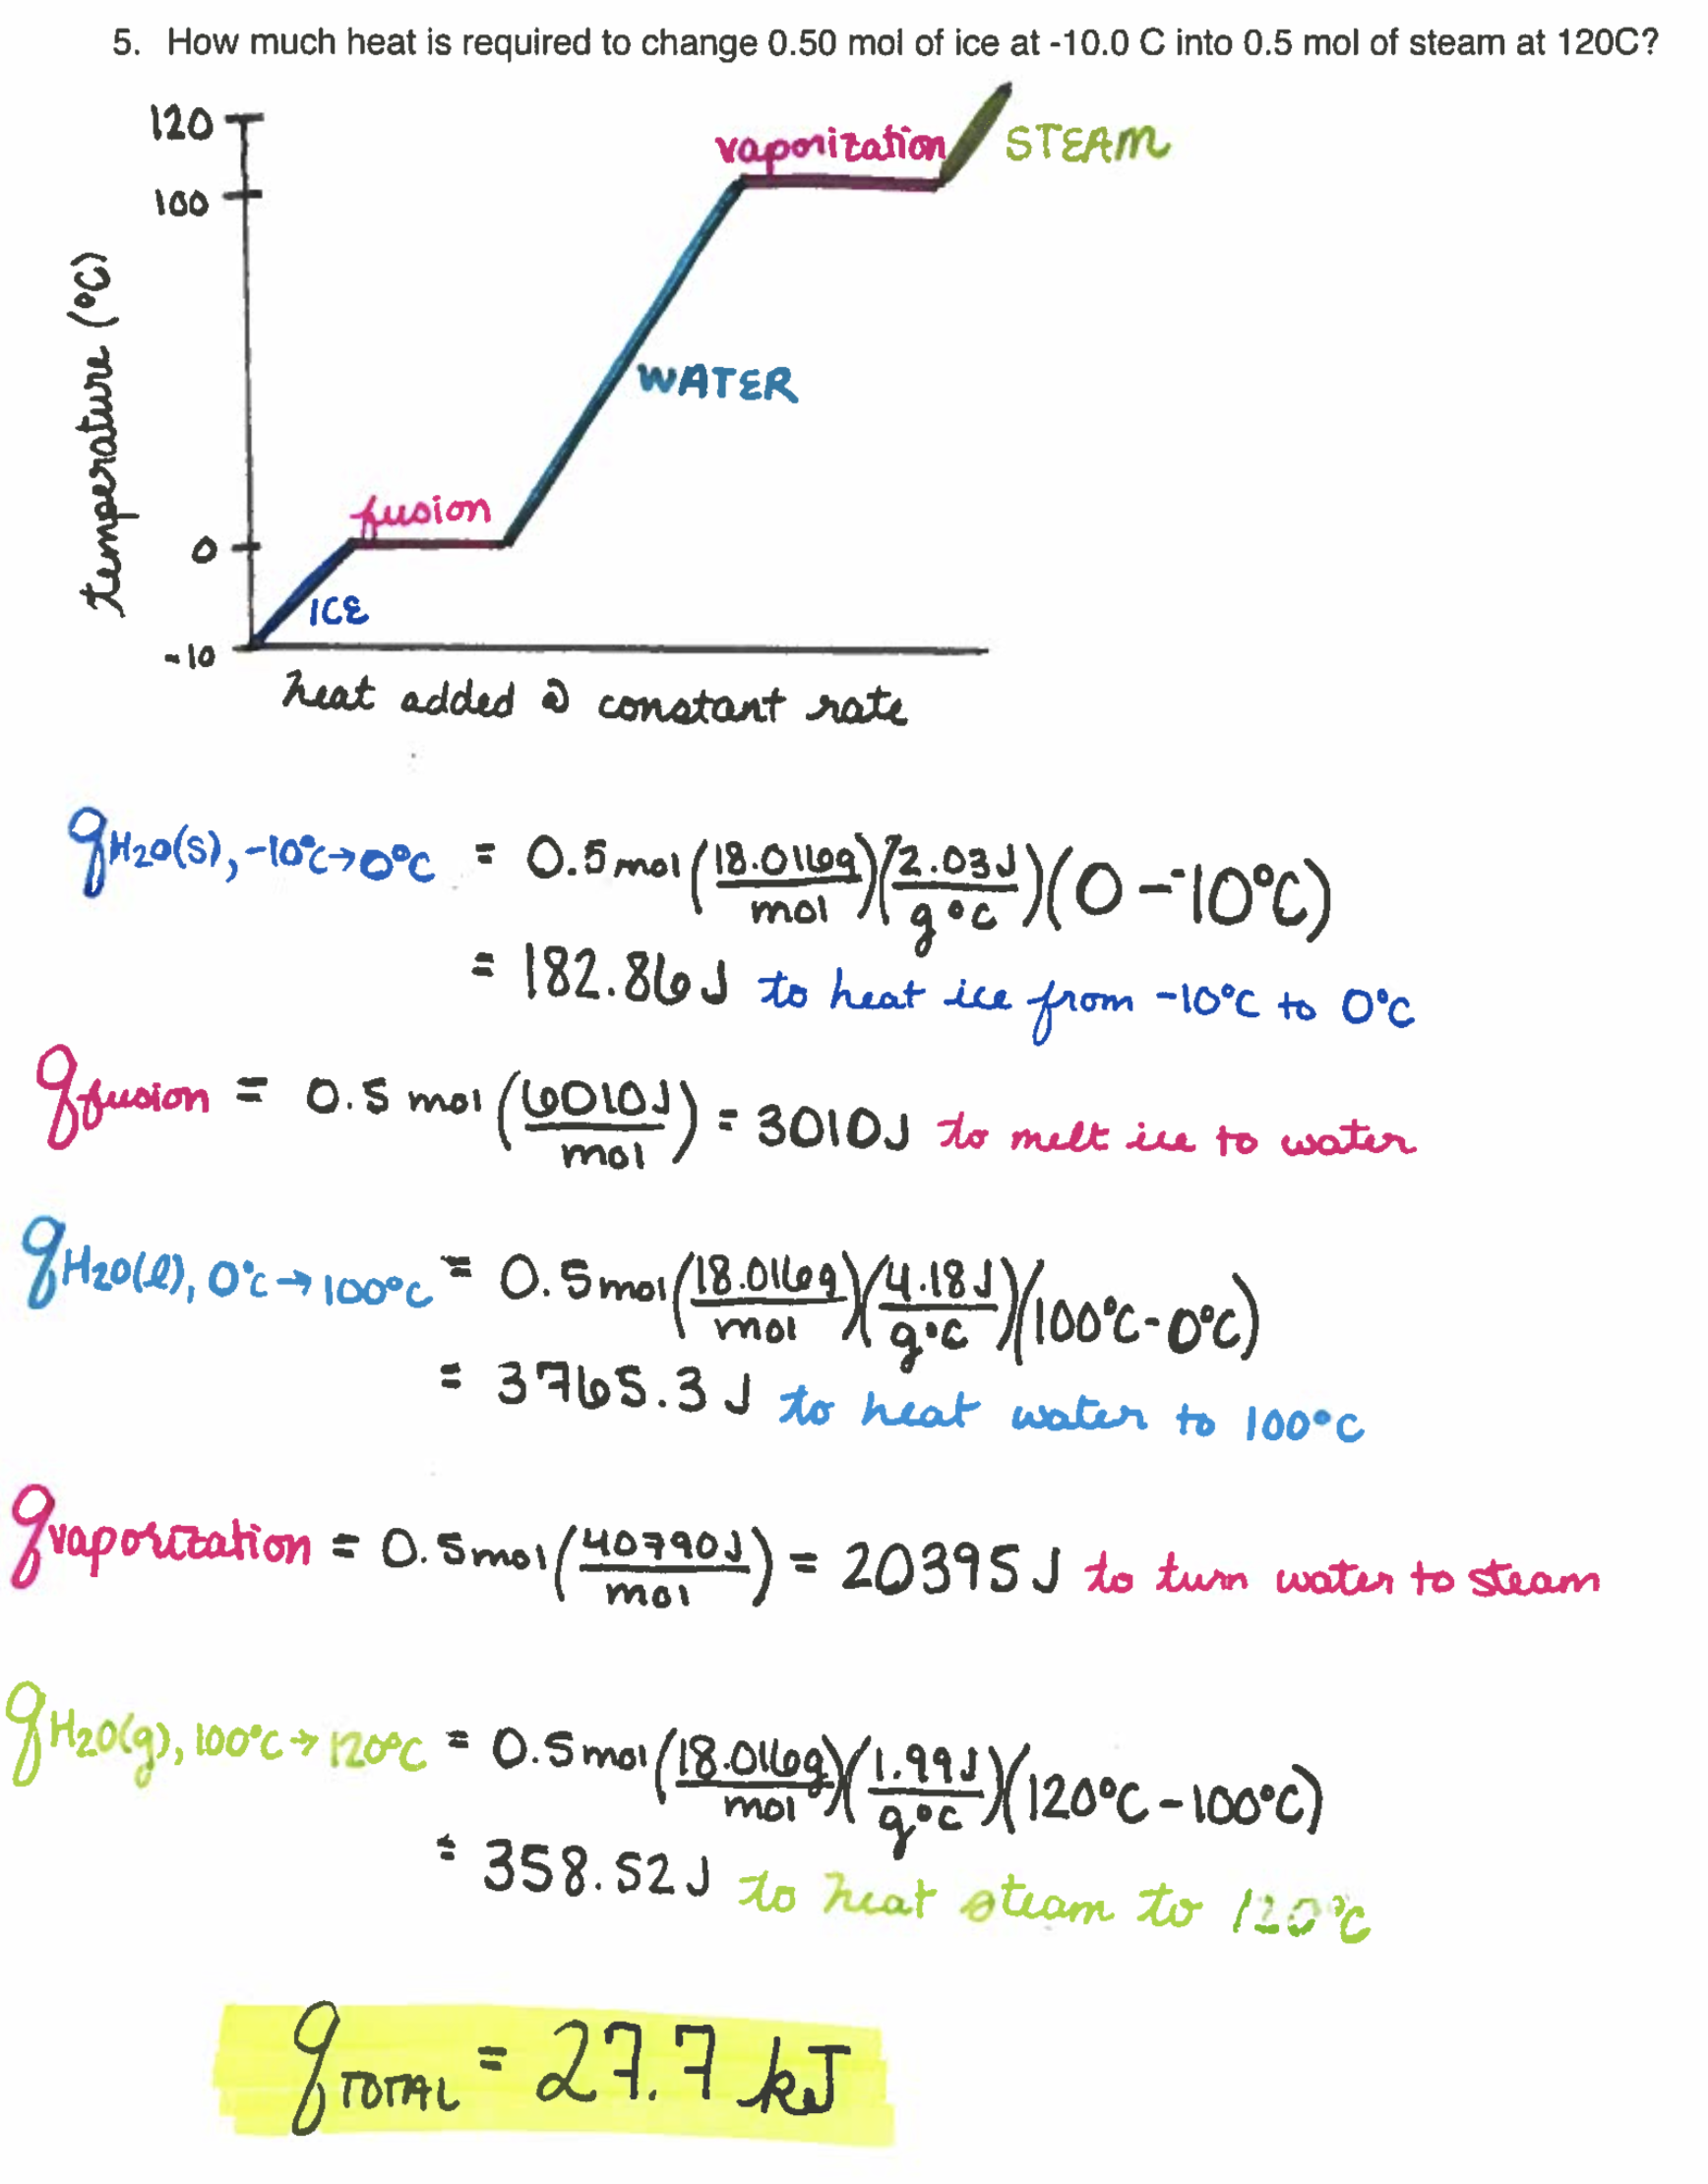

1. An ice cube at 0°C weighing 100 g is dropped into 1 kg of water at 20°C. Does all of the ice melt? If not, how much of it remains? **What is the final temperature?**

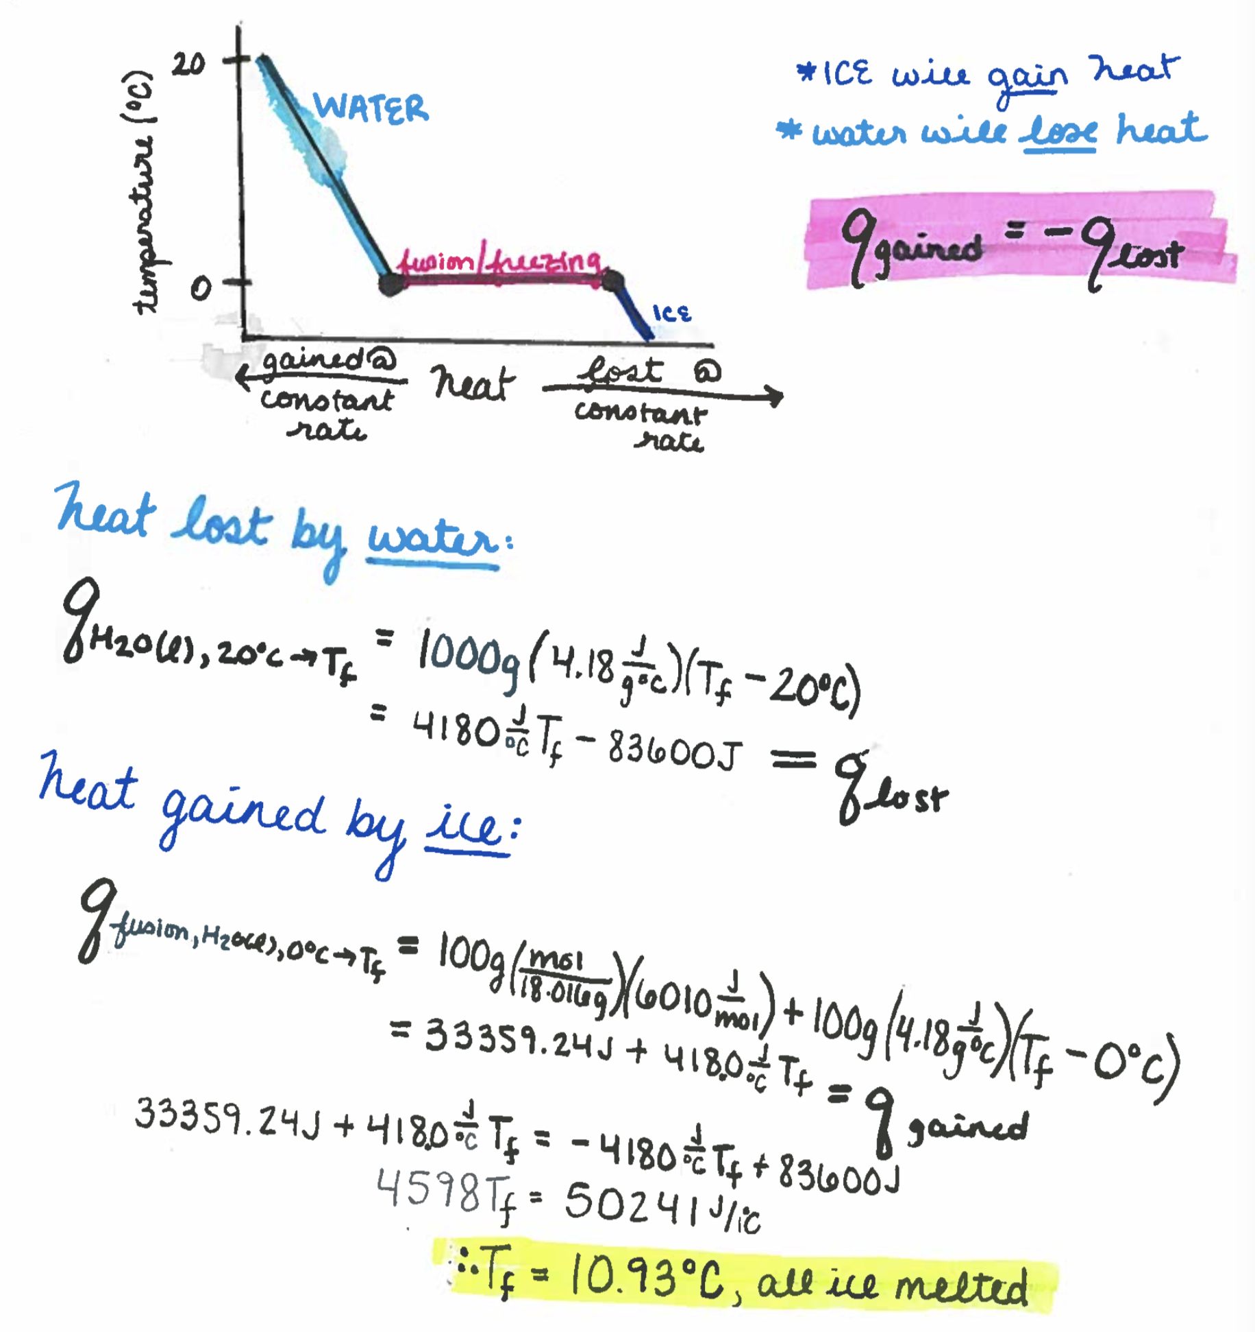

* 1. Now consider 10 ice cubes at 0°C, each weighing 100 g are dropped into 1 kg of water at 20°C. **Does all of the ice melt? If not, how much of it remains? What is the final temperature?**

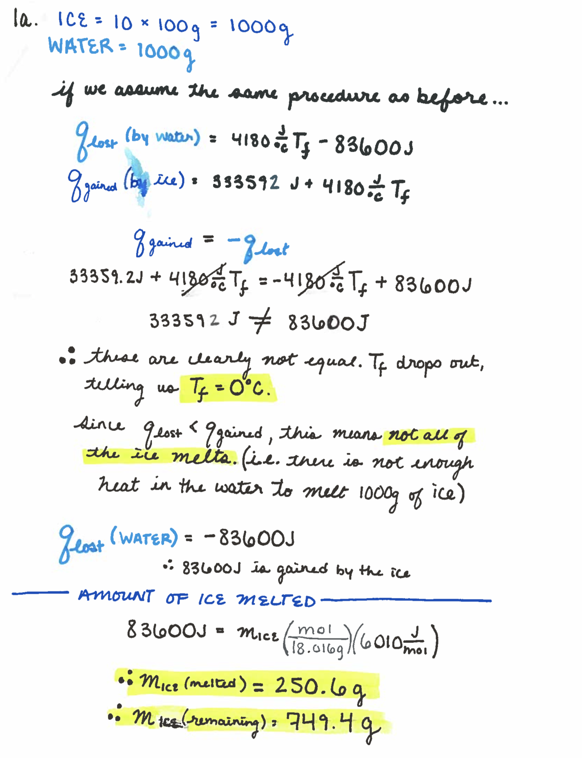

1. Rank the following in order of increasing polarizability and predict the order of their boiling points:
   1. F2 <CH4 < C2H4, < C2H5OH < CH2CH2CH2OH higher bP == higher polarizability
   2. CH4 < CH3CH(CH3)2 < CH3CH2CH2CH3
2. List the types of intermolecular forces that exist between molecules in each of the following species:
   1. CF2H2 – LDF, dipole-dipole
   2. FCN – LDF, dipole-dipole
   3. CH3NH2 – LDF, dipole-dipole, H-bonding
   4. H3COCH3 – LDF, dipole-dipole
   5. CH3Cl – LDF, dipole-dipole
3. 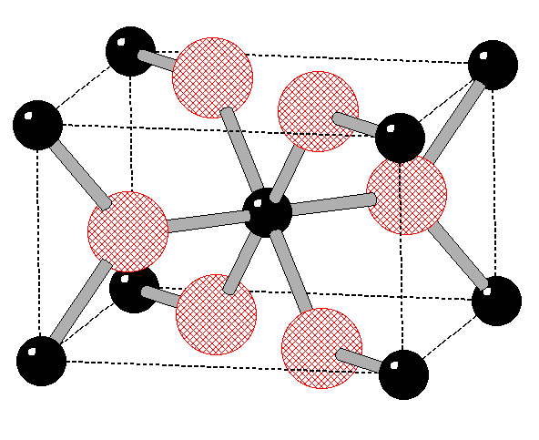The mineral rutile crystalizes in a structure with 8 corner titanium atoms, 1 central titanium atom, 4 face oxygens, and 2 central oxygens. What is the structural formula for rutile? (This is a tetragonal structure and you aren’t responsible for memorizing it, but treat it like a bcc/fcc hybrid)

$8\left(\frac{1}{8}\right)+1\left(1\right)=2 titanium atoms$

$4\left(\frac{1}{2}\right)+2\left(1\right)=4 titanium atoms$

**Overall: Ti2O4 which reduces to TiO2.** TiO2 can crystallize in many different structures, called polymorphs, but rutile is the most common and most stable.

1. Calculate the amount of heat given off when 138 g of steam at 172 ºC is converted to ice with a temperature of -10 ºC.

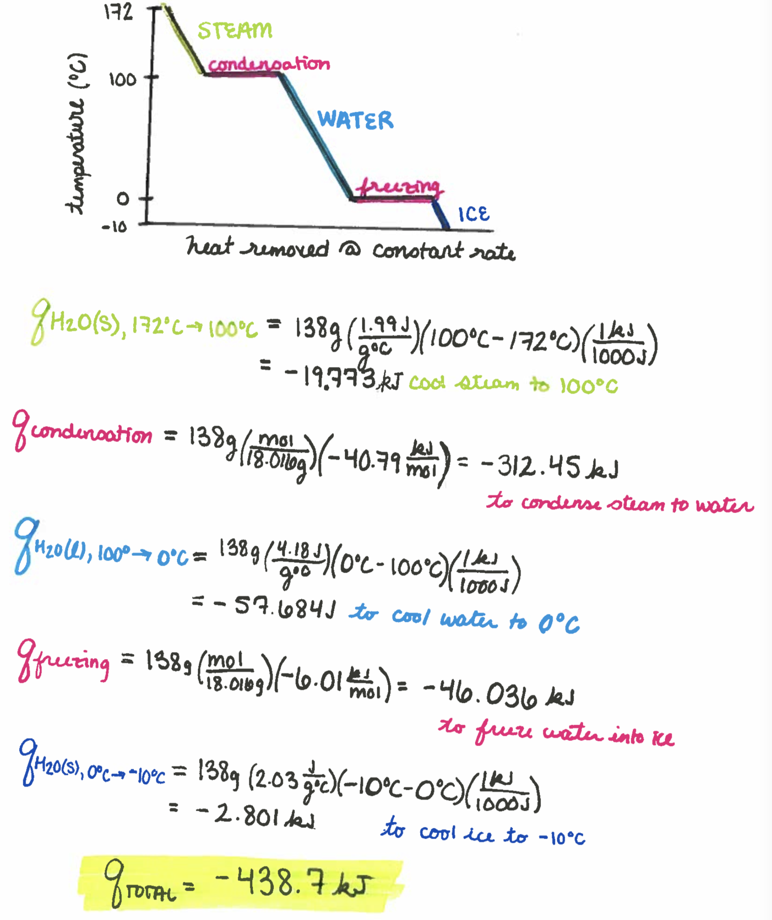



1. Use the phase diagram of xenon (shown at the right) to answer the following questions.
2. When solid xenon is warmed at atmospheric pressure, does it melt or sublime? At what temperature does this occur? What happens if solid xenon is warmed at 0.5 atm?

@ 1 atm – xenon MELTS at ~160K

@ 0.5 atom – xenon SUBLIMES at ~110K

1. What term is used to refer to point A on the phase diagram?

The triple point, where all three phases intersect.

1. What phase(s) is present at 1 atm and 50 K?

Solid

1. What phase does xenon occupy at standard temperature and pressure?

Gas

**Chapter 15:**

1. What is the pH of a solution made by mixing
   1. 750 mL of 0.400 M NaOH and 250 mL of 0.800 M HCl? Strong-strong titration
   2. 100 mL of 0.100 M NaHCO3 and 200 mL 0.100 M H2CO3? Buffered solution
   3. 100 mL of 0.250 M NaHCO3 and 50 mL of 0.1 M NaOH? Weak acid titration
   4. 100 mL of 0.250 M NaHCO3 and 50 mL of 0.1 M HCl? Weak base titration

